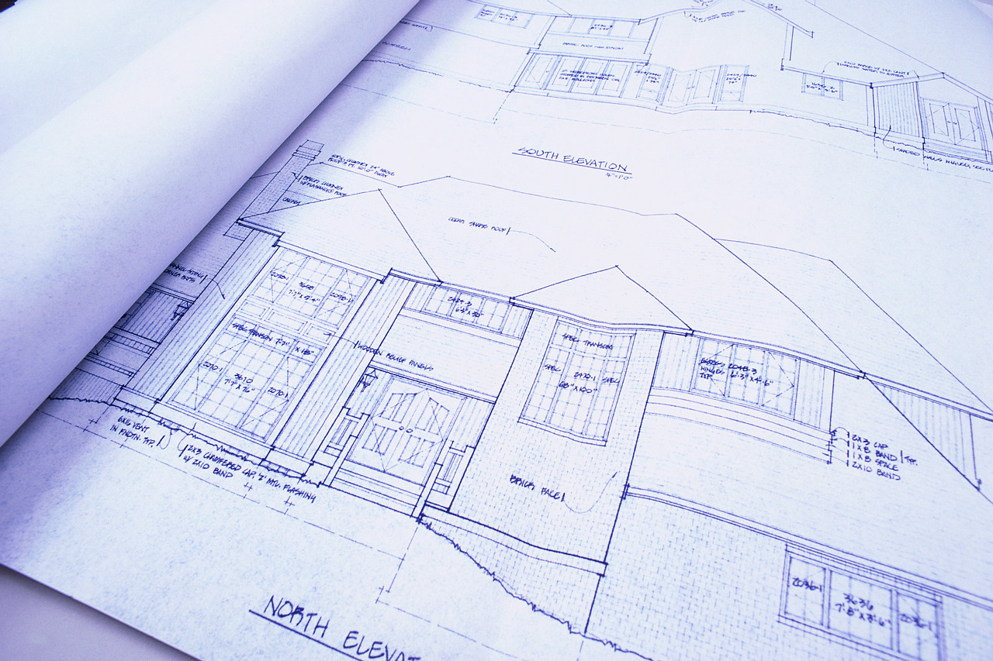
Architectural Guidelines

integrated pest management – Design considerations for schools

Developed in consultation with Safer Pest Control Project, Gregg

Smith (Salt Lake City School District) and David L.

Shangle B.C.E., Dalsh Consulting

Below are general design and construction guidelines for discouraging a variety of arthropod and vertebrate pests. You can establish more specific guidelines by determining the pests that are typical in your area, and undertake building design with them in mind.

- Entrance Ways –
  - Outside doors outfitted with door sweeps that fit snugly against the threshold and are flush with the doorframe on both sides. Sweeps can be either the brush or rubber variety.
  - Weather-stripping on doorframe along both sides and top of frame.

- Windows –
  - Incorporate windows which can accommodate screens.
  - Screens that are taught, without tears, and sealed tightly around the frame with a gasket.
  - Use aluminum, 10 mesh or smaller (aluminum can be stretched more tightly).
  - Weather stripping around window frame for a tight seal.
  - Incorporate small window ledges to deter perching birds.

- Caulking/Sealing – eliminate holes, cracks, crevices, and gaps:
  - Larger holes (pipe openings, etc.): stuff steel wool inside, and then fill with mixed cement or quality butyl caulk.
  - Smaller openings: should be caulked and/or sealed using elastomeric silicone sealant.
    - Throughout Building: along baseboards, floor and wall joints, window and door moldings, edges of electrical outlet covers, and radiator covers.
    - Pipes/Wiring: around all water, electrical pipes, cable and/or other wires coming into a unit.
    - Kitchen/Bathroom: around sink edges, where cabinets and countertops meet walls (particularly under the sink), between cupboards and countertops.

- Landscaping – trees, shrubs, and ornamentals that are:
  - At least 1’ away from the building.
  - Spaced far enough apart for 1’ separation at full growth.
  - Leaves, branches that have some ground clearance.

- Outside Air Intakes/Vents – screened with 10 mesh or smaller; fabricated and installed to be easily removed for cleaning. Area to consider:
  - Foundation Vents: many vents are constructed with screens; one should be fabricated for those that are not. Screen-weep holes.
- Floor Drains – Course mesh screens or floor sink baskets should cover drains or sunken floor drain baskets. Covers or baskets must be removable for cleaning.
- Waste Management – Replace dumpsters with self closing garbage compactors. Place recycle bins on concrete pads and lids must be kept closed. All compactors, dumpsters, recycle bins should be placed at least 50 feet from the building or more if possible/practical.

General Design Tips

Avoid:
- Nooks and flat ledges
- Lights above doorways; use reflected light to illuminate doorways
- Vegetation against the building (this includes grass)
- Pipes, electrical conduits, or hoses against walls
- Pipes entering drains that prevent drain maintenance
- Inaccessible drains under fixed kitchen equipment
- Equipment legs in inaccessible corners (corner-cleaning must be as easy as possible)

Limit:
- Alcove areas, which gather debris and serve as pest harborage areas

Use:
- Sloped or rounded decorative ledges and/or window frames
- Outdoor lights positioned away from entrances
- Non-vegetative boarders against buildings (gravel, etc.)
- Downspouts should be mounted 4-6 inches from building sides using spacers
- Concrete turf boarders at turf level so grass mowers can mow over them
- Self-closing trash cans which are elevated off the ground and set in a concrete slab


Build Pests Out
so we can keep our kids in!

